**Disruptive technologies are redefining Vancouver SEO**

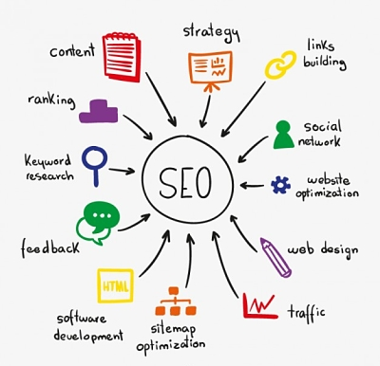

IoT (Internet of things) is one of the biggest technology developments of the past decades, and now is having a major impact in Vancouver SEO strategies.

Internet of things makes reference to items who were not previously conceived as digital devices but now they are. They have become digital because they have been redesigned and a wifi connection has been incorporated to them.

Some of the most well known Iot devices are the electrodomestics at a smart home, the oven or even the fridge are now connected to the internet.

This technology is becoming more and more popular and it is expanding to new environments besides domestic spaces.

The trigger factors behind the rise of Iot’s popularity are the enhanced asset utilization and saving up thanks to technology. Reducing expenses is quite easy with **Iot** since devices will be automatically turned off when they are not longer being used. This simple but important skill will not only help you save money but i will also contribute to saving the planet.

Iot enhances the possible uses of regular items. Just with a wifi connection your fridge will now be able to send you text messages telling you what should or shouldn’t be on your groceries shopping list.

Marketers are now putting all their efforts into becoming the top provider in their industry so Amazon sees them as the best candidate for Dash Buttons. Dash buttons are these sticky buttons with a Wifi connection, placed on walls and cabinets all around the house. Thanks to its **wifi** connection, customers will be able to replace products automatically. Consumers just have to press the button and it will instantly order the product using their Amazon account.

This is definitely having a major impact in the way marketers are orienting their new campaigns.

Besides Iot, there are other disruptive technologies redefining [Vancouver SEO](https://www.wittycookie.ca/seo/) rules. For instance, Artificial Intelligence or Voice assistants are changing the way people perform searches.

More and More users rely on voice assistants to perform a search. Voice assistants such as Alexa, Google Home or Google assistant which are based on speech recognition and voice interaction.

Due to how popular these digital assistants have become, companies must identify the differences between **keywords** typed into a search engine and sentences used in voice search.

Brands have to make sure they rank first since voice assistants usually only show the top result for *general questions.*

Therefore, featured snippets are now more important than ever. For voice search, traffic is not as relevant as **featured snippets**. Featured snippets are crucial since they are usually answers and users of voice search generally ask full sentence questions. A **brief and concise** featured snippet can take your company to the first position.

Other factors such as **pagespeed and HTTS** can contribute to getting the first position. On average websites shown on voice-activated assistants load faster than websites shown on search engines. They usually loads in 4.6 seconds.

Indeed, Iot and voice-activated assistants are changing the rules of Vancouver SEO. And, in general, there are disruptive technologies changing the way of doing business.

The use of Artificial Intelligence, advanced telecommunications services, such as a [Call center software](https://www.fonvirtual.com/en/call-center-software/), and virtual reality in business is now a fact. The way of doing business is expected to drastically change in the following years due to these innovations.

Companies must embrace these technologies and take the opportunity to become a first-mover. [Wittycookie](https://www.wittycookie.ca/) is the SEO expert page that will give you the best guidelines to follow to take your business to the top.

*Emma Smith, PR and content manager at* [*Fonvirtual*](https://www.fonvirtual.com/en/)*. Fonvirtual provides companies and entrepreneurs with international virtual phone numbers and other virtual services. I’m interested in digital marketing, technology and international logistics. I am a usual collaborator in blogs, where I try to spread the word of telecom services in international business.*